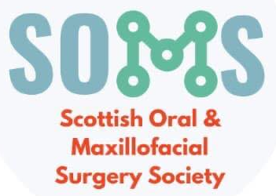

GDC development outcome C

Aims
To provide an update on the management of facial trauma
To gain an insight into the Scottish Cleft Service
To discuss recent advances in head and neck cancer treatment

Objectives
To share a reflection on the career of a facial trauma surgeon
To provide an update on mandibular reconstruction
To discuss how OMFS trauma management has been affected by the Covid 19 pandemic
To provide an update on sentinel lymph node biopsy
To outline the dental rehabilitation of patients with low-level malignant maxillary tumours
To provide an update on oral medicine for oral and maxillofacial surgeon

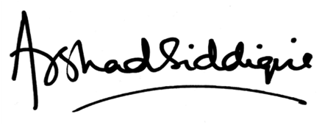
Mr. Arshad Siddiqui
Consultant Oral and Maxillofacial / Head and Neck Surgeon
(Edinburgh)
& SOMS -2021 organizing committee

